**Group name:** The Shifters

**GitHub Project URL:** https://github.com/fabmouse/The-Shifters

**Group members:** Tshegofatso Molobe, Brooke Franklin, Litha Stuurman and Tapiwa Pawandiwa.

**Group mentor:** Kristen Theunissen

**Project Title:** The Shifters Café Takeaway and Rhodes Campus Delivery System

**Project Description:** This program is designed to be used at a restaurant that has a takeaway and delivery service. The delivery service for this program currently works for the Rhodes University Campus.

**Instructions for using the Application (allowable actions):**

There are two sides to the application: the Manager’s side and the Teller’s side. Fig1(a) shows the Main Window that is opened when the program starts. By selecting a user, either Manager or Teller, a user login window opens, like the one shown in Fig 1(b).

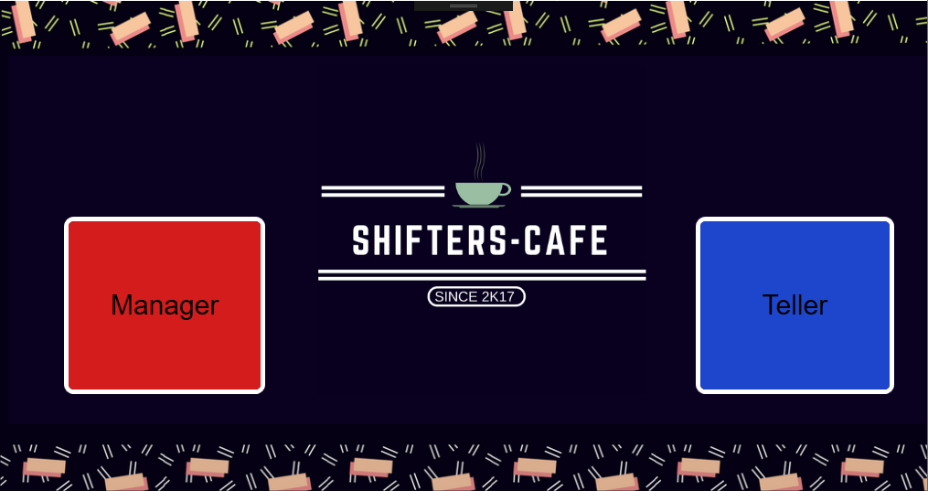 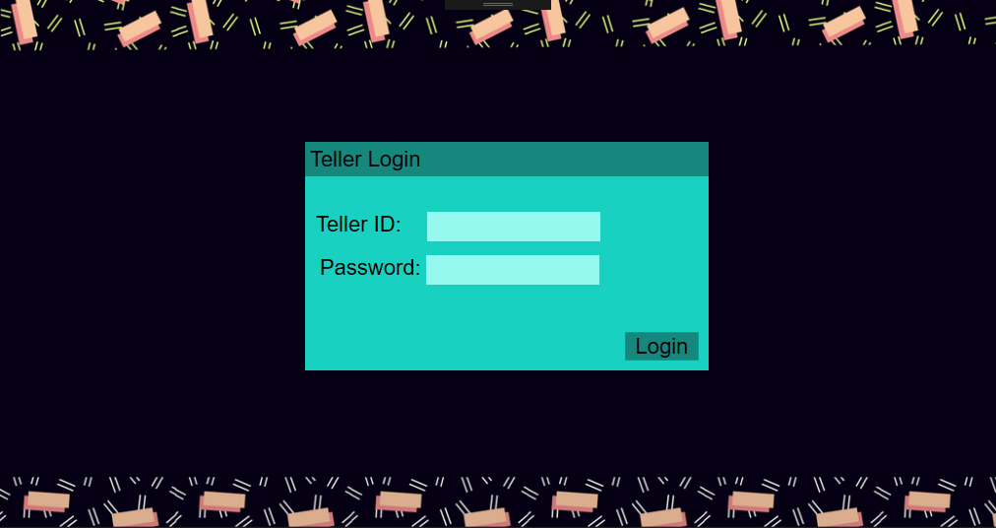

*Fig 1(a). Main Window Fig 1(b) User Login Window*

|  |  |  |
| --- | --- | --- |
|  | User ID | Password |
| Teller Side | TelFB1 | HelloWorld |
| Manager Side | ManPT1 | Password |

**Note: To login please use the following information:

The Teller Side:

The Teller side is navigated using Tab Control as shown in Fig 2.

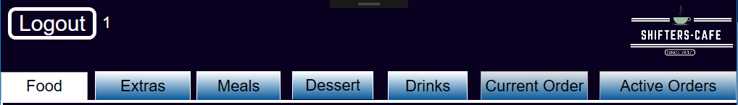  
*Fig 2. Teller Tab Control*

The Menu is contained in a text file that is automatically uploaded when the program is started (See Appendix 1).

Navigating The Menu

The menu is navigated using Tab Control. There are five tabs for Menu Items, namely: Food, Extras, Meals, Desserts and Drinks (See Fig 2). Each Menu Section Tab allows for the selection of a Menu Item and the description of that item will automatically be shown in a display box to the right of the menu.

Adding Items to/Removing Items from an Order

Items are added by selecting an item from the list box and clicking the “Add Item” button available at the bottom of each Menu Section Tab. The list of items ordered can be found under the Current Order Tab.

Box Meals come with a choice of Coca-Cola drink. The teller must select a drink in order for the order to be added. Note, the size of the Coca-Cola drink is not optional in the case of Box-Items.

If a mistake has been made in ordering, the teller must go to the Current Order Tab and remove the item that was incorrectly added. This does not have to be done immediately, but can be done at any time before the order is completed. Manger approval will be needed and a Manager Login window will pop up in order to allow the item to be removed.

Completing an Order

An order can either be for takeaway or for delivery to students living on Rhodes University campus. The type of order can be chosen by selecting the appropriate check box next to the order window. If a checkbox is not selected the order cannot be completed.

A Takeaway Order:  
When completing a takeaway order, the teller must ensure that the customer has paid before the receipt can be printed. The total price of the order and the necessary change are calculated automatically. The receipt produced contains the café information, date, teller who put the order through, the details of the customer’s order, the cost of the order, amount paid and change received, as well as an order number (which is called when the order is ready to be collected).

The Shifters Café  
Grahamstown  
012 3456 789

[Date]  
Teller: ***

[Customer’s Order]

*Prices include VAT.  
Total Cost: ###  
Total Paid: ###  
Change: ###

Order Number: ##

*Fig 3. Example of Takeaway Receipt*

The takeaway order will then be placed on a takeaway list under the Active Orders Tab.

A Delivery to Rhodes Campus Order:  
When completing a delivery order, the teller must ensure that the customer details have been supplied (the customer name, contact number and residence) before the receipt can be printed. The customer details must be in the correct format:

* Customer name: must be strictly made up of letters.
* Customer Contact: must be strictly 10 digits long and made up of numbers.
* Customer Residence: must be a valid Rhodes University Residence.

The total price of the order is calculated automatically. The receipt produced contains the café information, teller who put the order through, the customer details, the details of the customer’s order as well as an order number (so that the drivers know which orders they are responsible for).

The Shifters Café  
Grahamstown  
012 3456 789

[Date]  
Teller: Name

Customer Name: ***  
Contact Number: ###  
Residence: ***

[Customer’s Order]

*Prices include VAT.  
Total Cost: ###

Order Number: #

The Shifters Café  
Grahamstown  
012 3456 789

[Date]  
Teller: Name

[Customer’s Order]

*Prices include VAT.  
Total Cost: ###

Order Number: #

*Fig 4a. Example of Fig 4b. Example of   
Delivery Receipt for the driver Delivery Receipt for the customer*

The delivery order will then be placed in a delivery list, depending on which campus the order is for, under the Active Orders Tab.

Active Orders:

The Active Orders Tab displays the orders that have been put through for takeaway and delivery to the three campuses. There are three lists for delivery to Lower Campus, Middle Campus and Upper Campus and there is one driver assigned to each campus.

The Manager Side:

The Manager side is also navigated using Tab Control.

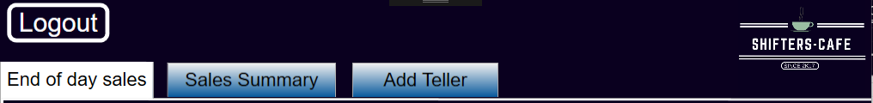

*Fig 4. Manager Tab Control*

End of Day Sales:

This Tab displays the order number, TellerID, customer’s order and total cost of all orders processed that day. This information is also saved to the “Summary Food” text file (See Appendix 1) which can be printed at the end of each day for record purposes. The file can also be cleared of all orders for a new day using the reset button under the Summary Sales Tab.

Sales Summary:

This Tab displays a summary of the sales information for that day. The left hand side displays a summary of the cumulative number of sales of each food item. The right hand side displays the total amount earned from all sales, the total number of orders, the total number of delivery and takeaway orders as well as the most popular item(s). This summary can then be reset using the reset button.

Add Teller:

A new teller can be added to the system under the Add Teller Tab. The Teller ID is automatically generated using the phrase “Tel”, the first letter of the surname, the first letter of the first name and a Teller number. For example, if Moo Cow is the fifth teller to be hired at Shifter’s Cafe, their teller ID is given by TelCM5.

Appendix 1

Text Files

The program uses six text files for uploading and saving information.

|  |  |
| --- | --- |
| File Name | Information Format |
| Food | MENU SECTION  Food Item;Description;Price  MENU SECTION  Food Item;Description;Price  **.**  **.**  **.**  **Menu Section Names: Burgers, Pizzas, Extras, BoxMeals, Desserts, Drinks |
| AllOrder | Order Number:  Teller:  [Customer’s Order]  Total Cost:  **This text file is automatically updated once an order has been completed and can be reset by a Manager. |
| Summary Food | Total Sales; cumulative total  Total Orders; cumulative total  Total Takeaways; cumulative total  Total Deliveries; cumulative total  Food Name; cumulative total  **.**  **.**  **.**  **This text file is automatically updated once an order has been completed and can be reset by a Manager. |
| Teller Passwords | TellerID;Password;Teller Surname;Teller Firstname  **This text can be added to by the Manager under the Add New Teller Tab. |
| Manager Passwords | ManagerID;Password; Manager Surname; Manager Firstname |
| Campuses | CAMPUS:LOWER  Residence Names  CAMPUS:MIDDLE  Residence Names  CAMPUS:UPPER  Residence Names |

**Tools or Concepts Used:**

1. Text Files
2. GUI Objects (Textboxes, Listboxes, Checkboxes, Buttons)
3. Event Handlers
4. Classes and objects
5. Overriding
6. Interfaces
7. Dictionaries
8. Exceptions
9. Data Validation and Verification

**Our Assumptions:**

We assume that the Tellers and Managers will be computer literate.

If the information in the files is edited by hand, it will be done so in the format specified by Appendix 1.

New managers will be added to the text file by hand and not from the program

**Our Limitations:**

Our delivery service is only limited to Rhodes University Campus.

We cannot remove individual items from an order e.g. if a customer would like a Vegetarian Pizza with no avocado slices.

Pizzas and drinks do not come in different sizes.